WAITING LIST OPEN
06/23/26 -06/25/26
9:00AM - 4:00 PM
06/26/26- 9:00 AM - 12:00 PM

2 BED/ 3 BED/ 4 BED UNITS FULL KITCHEN
ONSITE PARKING ONSITE LAUNDRY
WASHER/DRYER HOOK UPS IN MOST UNITS
PATIOS
HOUSEHOLD MAXIMUM INCOME LIMIT:
2 PERSON - $62,600 6 PERSON - $90,750
3 PERSON - $70,400 7 PERSON - $90,750
4 PERSON - $78,200 8 PERSON - $103,250
5 PERSON - $84,500
**Las Casas de Madera Cooperative, INC. requires the purchase of a cooperative membership. The membership fee is due at the time of move-in and ranges from
$3,500 to $5,500, depending on unit availability.

LAS CASAS DE MADERA
Las Casas de Madera Cooperative, Inc is pleased to announce the opening of our HUD Project Based Section 8 waiting list.

Applications can be submitted via email or in person. Applications will be accepted only during the times noted below:

06/23/26-06/25/26 From 9:00am to 4:00pm
06/26/26 From 9:00am to 12:00pm

Applications are accepted in accordance with HUD guidelines. Las Casas de Madera will make a reasonable accommodation to assist in the Application process if the applicant or any member of the applicant family is disabled. All completed applications must be submitted to the leasing office either in person or via mail.

CONTACT US





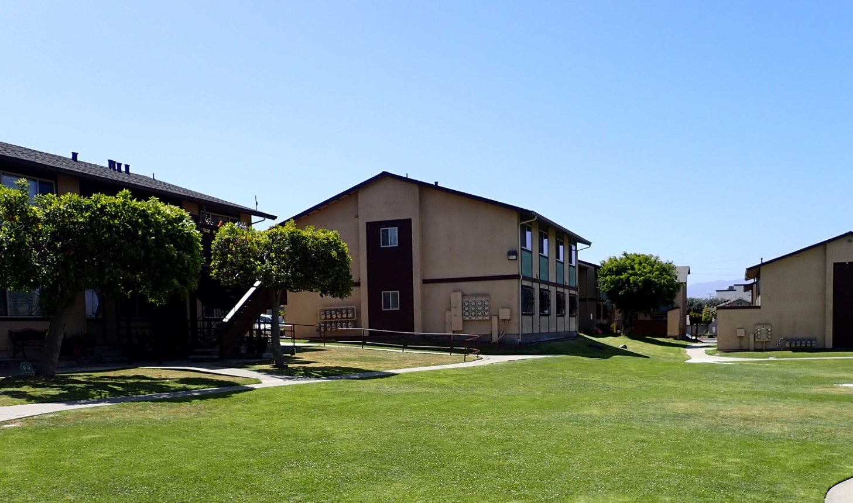

510 E Market St, Salinas CA 93905
PHONE: (831) 422-5131
Email: lascasas@loganpm.com

